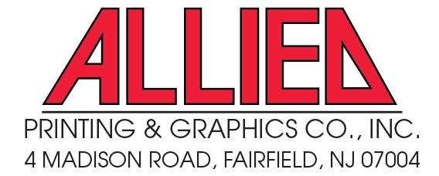 |  | Purchase Order  April 11, 2024
SALESPERSON
Lisa Westbrook
(P) 973-227-0520 lisa@alliedpng.com
(F) 973-227-7664 asi # 118551

To | GBAG  (408) 395-6889  info@gbag.net | BLIND SHIP  TO | The Aesthetic Show 2024  c/o LVE-IT Vegas  6225 Annie Oakley Drive  Las Vegas, NV 89120  Attn: Show Mgmt - Show Bags

PO # | SHIPPING CARRIER | SHIPPING METHOD |  | DELIVER BETWEEN
241054 |  | Best Way |  | May 20 – June 10, 2024

item# | DESCRIPTION | QTY | unit price | line total
 | 135g Non-Woven Tote Bag with Gloss Lamination, Self-material piping | 1,000 | $1.55 | $1,550
 | Print CMYK + Silver
 | 14” X 11” x 4” with 20” webbing handles
 | Repeat MD logo
 | Plate charges | 5 | $125 | $625
 | Freight |  |  | $300
 | Please attach provided shipping label to cartons
COMMENTS: |  | total |  | $2,475
Sample photo requested
Please send me tracking number when order ships.
Cartons must include a packing slip.

