PURCHASE ORDER

Midwest Stitch
6767 Charles St. Rockford, IL 61108
(815) 394-1516 FAX(815)394-8975
P.O. #: | Adams Totes
DATE: | 10/27/23

TO:
GBag
Attn: Anna Hanna
QTY | DESCRIPTION |  |  | UNIT PRICE | EXTENTION
Adams Fairacre Farms
Full print with “I only came in for One thing’ picture and stripes
Green handles
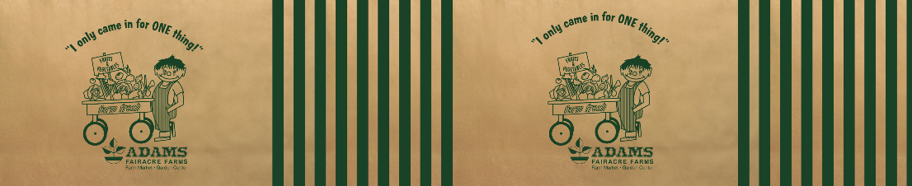
New order

5000 | Collapsible Bag |  |  | 1.79 | 8950.00
16”W x 11”H x 10”D
Matte Laminated Woven PP
Webbing Handles – color to match #21 Swatch
5000 | Shipping |  |  | .45 | 2250.00
5 | Setup 5 plates for full color (CMKY brown paper + green) |  |  | 150.00 | 750.00
1 | Pre-Production Sample |  |  | 0.00 | 0.00
 |  |  |  | Total | 11,950.00
Please send a sample before mass production is approved

SHIP TO: |  | Midwest Stitch  6767 Charles St.  Rockford, IL 61108

