PURCHASE ORDER

Midwest Stitch
6767 Charles St. Rockford, IL 61108
(815) 394-1516 FAX(815)394-8975
P.O. #: | Adams Totes
DATE: | 11/11/22

TO:
GBag
Attn: Anna Hanna
QTY | DESCRIPTION |  |  | UNIT PRICE | EXTENTION
Adams Fairacre Farms
Full print with fruits/vegetables, both sides of brown bag

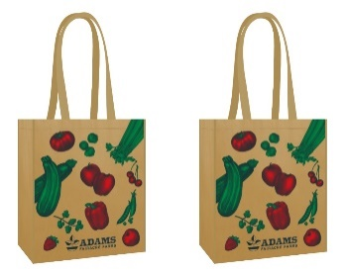
Repeat orders for Grocery, Cooler, Tyvek

15000 | Grocery Bags-- |  |  | .98 | 14700.00
SL1001 – 145 g Matte Laminated WPP –
13 x 15 x 8
20” webbing handles – color to match the brown bag #31
 | Piping: Brown Self Material
15000 | Shipping |  |  | .30 | 4500.00
5000 | Cooler Bags –  L5061-1 Matte Laminated Cooler Bag: 13 x 15 x 10  145 g Matte Laminated WPP  Piping: Brown Self Material w/ Velcro Closure |  |  | 1.90 | 9500.00
5000 | Shipping |  |  | .60 | 3000.00
5000 | Tyvek Bags –  Washable Bag: 12 x 14 x 7 |  |  | 2.25 | 11250.00
5000 | Shipping |  |  | .35 | 1750.00
 |  |  |  | Total | 44,700.00
Total of 25,000 bags

SHIP TO: |  | Midwest Stitch  6767 Charles St.  Rockford, IL 61108

