PURCHASE ORDER

Midwest Stitch
6767 Charles St. Rockford, IL 61108
(815) 394-1516 FAX(815)394-8975
P.O. #: | Adams Totes
DATE: | 08/16/22

TO:
GBag
Attn: Anna Hanna
QTY | DESCRIPTION |  |  | UNIT PRICE | EXTENTION
Adams Fairacre Farms
Full print with fruits/vegetables, both sides of bag
Brown colored grocery Bags

1625 | SL1001 – 145 g Matte Laminated WPP –  13 x 15 x 8  20” webbing handles – color to match the brown bag #31 |  |  | 1.39 | 2258.75
 | Piping: Brown Self Material
1625 | Shipping |  |  | .40 | 650.00
 | 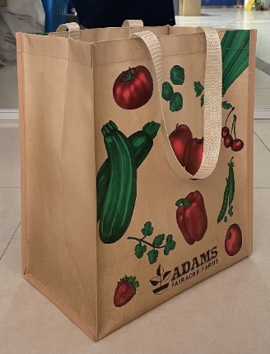
850 | L5061-1 Matte Laminated Cooler Bag: 13 x 15 x 10  145 g Matte Laminated WPP  Piping: Brown Self Material w/ Velcro Closure |  |  | 2.32 | 1972.00
850 | Shipping |  |  | .90 | 765.00
 | 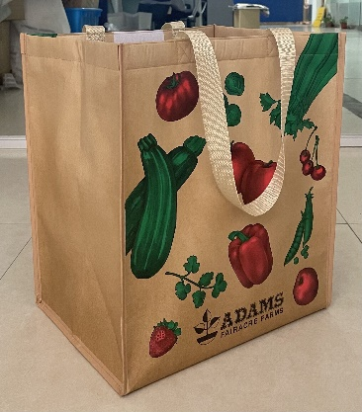
 |  |  |  | Total | 5645.75
SHIP TO: |  | Adams Fairacre Farms  Attn: Wendy Troncone  765 Dutchess Turnpike  Poughkeepsie, NY 12603

