PURCHASE ORDER

Midwest Stitch
6767 Charles St. Rockford, IL 61108
(815) 394-1516 FAX(815)394-8975
P.O. #: | Adams Totes
DATE: | 05/19/22

TO:
GBag
Attn: Anna Hanna
QTY | DESCRIPTION |  |  | UNIT PRICE | EXTENTION
Adams Fairacre Farms
Full print with fruits/vegetables, both sides of bag

Brown colored grocery Bags

3000 | SL1001 – 135 g top graded Matte Laminated NWPP –  13 x 15 x 8  20” webbing handles – color to match the brown bag #31 |  |  | 1.39 | 4170.00
3000 | Shipping |  |  | .40 | 1200.00
 | 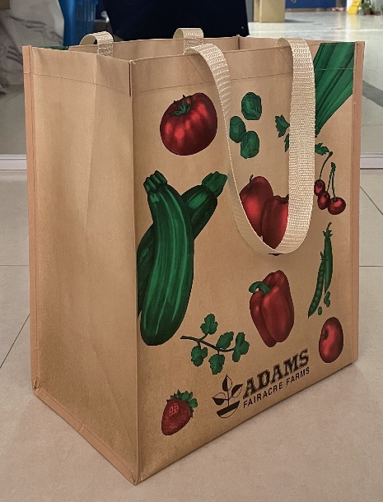
 |  |  |  | Total | 5370.00
SHIP TO: |  | Adams Fairacre Farms  Attn: Wendy Troncone  765 Dutchess Turnpike  Poughkeepsie, NY 12603

