PURCHASE ORDER

Midwest Stitch
6767 Charles St. Rockford, IL 61108
(815) 394-1516 FAX(815)394-8975
P.O. #: | Adams Totes
DATE: | 12/06/21

TO:
GBag
Attn: Anna Hanna
QTY | DESCRIPTION |  |  | UNIT PRICE | EXTENTION
Adams Fairacre Farms
Full print with fruits/vegetables, both sides of bag

Brown colored grocery Bags

3000 | Tyvek Washable Paper Bag: 12 x 14 x 7 |  |  | 2.50 | 7500.00
 | 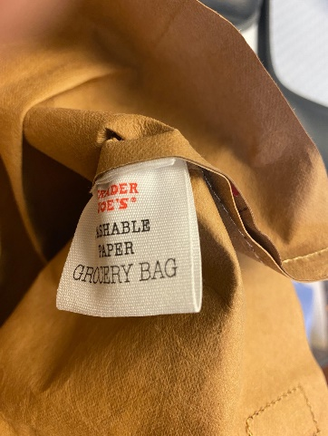
4 | Plate Charge |  |  | 135.00 | 540.00
1 | Pre-Production Sample |  |  | 298.00 | 298.00
3000 | L5061-1 Laminated Cooler Bag: 13 x 15 x 10 |  |  | 2.32 | 6960.00
4 | Setup Plate Charge |  |  | 135.00 | 540.00
1 | Pre-Production Sample |  |  | 298.00 | 298.00
3000 | SL1001 – 135 g top graded Matte Laminated NWPP –  13 x 15 x 8  20” webbing handles |  |  | 1.39 | 4170.00
4 | Setup Plate Charge |  |  | 135.00 | 540.00
1 | Pre-Production Sample |  |  | 298.00 | 298.00
 | 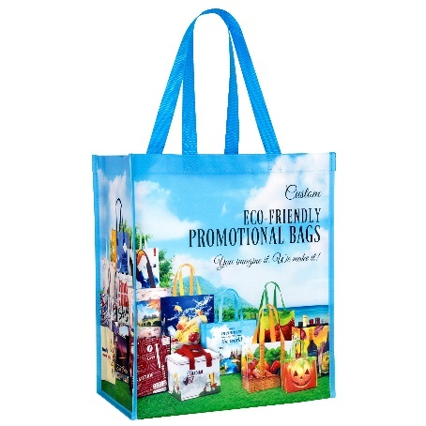
 |  |  |  | Total | 21,144.00
Ship to zip code 12528
SHIP TO: |  | Midwest Stitch  Carla Boggs  580 Milton Tpke  Highland, NY 12528

